Time in Pere Lachaise
On October 25, 2019 By julie pesanoEdit
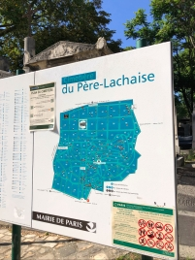I didn’t want to face all that death. For most of my life, I’d been dreadfully frightened of ghosts, hauntings, or horror movies. Call it a 6th sense or an active imagination, but I was known to get spooked by antique portraits, dark basements, and creaky floorboards. This visit felt like eerie immersion therapy. But after 25 years of traveling, teaching, and living in Paris, it was high time I finally went to Père Lachaise Cemetery – that famous final resting place of some of the greatest artists, writers, and musicians in France.
My plan was to get all left-brained about it. I would give myself three hours, plot my map route, and logically and systematically locate my five favorite writers. I was an English teacher after all, an academic, and perhaps if I could categorize and compartmentalize death, I would be less likely to let my right-brained imagination conjure up any ominous apparitions. 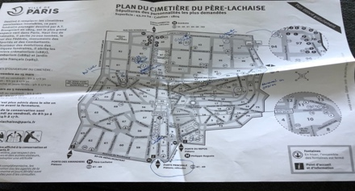
As I marched up the hill on Avenue Principal, the glorious autumn sun glimmered on marble stones and shimmered on amber oak leaves. Birds chirped, butterflies flitted, flowerbeds bloomed – all oblivious to the death around them. This was hardly the kind of day I had imagined for a cemetery. Where was the grey gloom, the drizzling rain, or the bitter cold associated with skeletons and sepulchers? No French frisson here.
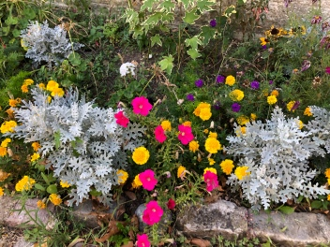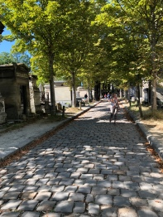
After a 15-minute stroll in this Edenic garden, I finally found Division 85, the square where Marcel Proust, the early 20th century French novelist was buried. Circling and circling this labyrinth of granite, slate, and sandstone was maddening. The jumble of graves were smashed within inches of each other, some massive monuments with life size statues, others were flat plaques with barely a name. A scratch of my head and a squint at my map drew the attention of an elderly gentleman on a bench who asked, “Qui cherchez-vous?” Who are you looking for?
Startled, I looked up to see a silver-haired man straight out of 1920’s Great Gatsby casting – tweed suite, wooden cane, fall cap.
“Marcel Proust, s’il vous plaît” I said.
Without hesitation, he smiled and pointed across the division, “Tournez-vous à droite, a mi-chemin.” Turn right, half-way down. “Merci beaucoup, Monsieur,” I said as I marched off in said direction. Sure enough, there was the famous writer Proust, just a black marble flat rectangle with only his name and the dates 1871-1922 engraved on the side. Sickly since his youth, he only lived to 51, and I wondered if the possibility of death hovering over him changed his perspective on life. His tome of a text, In Search of Lost Time explores the very nature of time, how the past is always present in our memories, how to stop wasting time and truly appreciate every moment now. I thought of the ancient two Greek concepts of time. Chronos is clock time, linear, logical, and man made. Kairos is sacred time, imaginative, and limitless. Proust knew that artists could tap into the state of kairos presence, so much that they could transcend time. 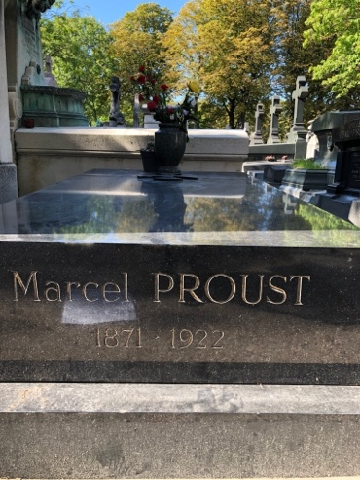
For a moment I flashed back to my classes in California when I would discuss an amazing piece of literature, and feel the students come alive in the beauty and depth of the words. Time stood still. Two hours felt like a minute. I wanted to be in that space forever.
My IPhone timer suddenly rang. I was already 30 minutes into my search for writers, and I had only found one. Time to move on. A glance at my map, and I headed for Oscar Wilde’s grave in Division 89 a couple of blocks away. Stopping at the corner of Avenue Angelo and Avenue Transversale, I noticed the same old man sitting on another bench. I smiled at him and asked, “Oscar Wilde, s’il vous plaît?” Again, he confidently motioned right then left. Did this guy work there? No, he just seemed to love the cemetery, loved spending time in this beautiful park and helping people find grave sites.
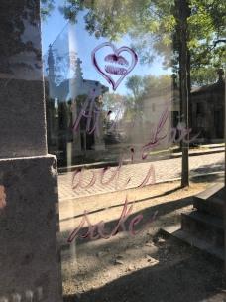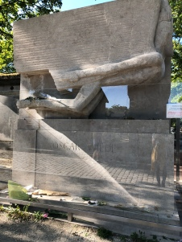
I spotted Oscar Wilde from a distance. Surrounded by 6 or 7 picture takers, this huge slab of stone was the size of a dump truck. Carved into the center was an Egyptian looking winged figure, swiftly moving forward in flight. The tomb seemed as flamboyant and flashy as the dapper 19th century Irish dandy. Since 1990, the site had been enclosed in glass to protect it from the lipstick kisses and love letters written mostly from women to the openly gay writer. Wilde only lived 46 years, but in that time seemed to lead a life of pleasure, eccentricity, and love as seen in his most famous works, The Importance of Being Ernest and The Picture of Dorian Gray. In the latter, he wrote, “Some things are more precious because they don’t last long.” I too was in my late forties and suddenly felt like every moment past Wilde’s 46 was perhaps stolen time.
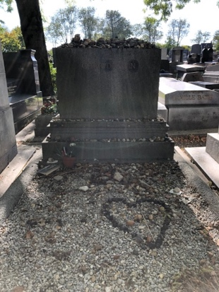Jumping forward in distance and time, I walked the perimeter of the cemetery to Gertrude Stein’s grave in Division 94 to find a woman who truly knew how to live. In her 72 years, this American author of German-Jewish descent spoke multiple languages, got her medical degree in a time when women rarely went to college, and held salons at her Paris apartment for some of the best writers and artists of the early 20th Century. She even lived openly with her lover Alice B. Toklas, whose name was engraved on the back of her tombstone. The simple but solid square site was covered in small stones, a Jewish tradition of honor. As I moved closer, I noticed pebbles in the shape of a heart in the center of the grave, so many people still affected by the memory of her life. I wondered how I might be remembered, if at all, decades after my death, if any stones would be placed on my grave.
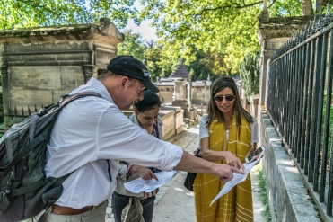Checking my watch, I realized I was running out of time. I scurried down the hill towards some levity and the grave of Molière, the 17th century comedic playwright famous for such farces as Tartuffe a bawdy rousing romp of mistaken identity and seduction. Molière humorously even wrote about death, “We only die once, but for such a long time.” I found the street Chemin Molière et LaFontaine, but in this older section of tangled paths and irregular sections, I was lost. Looking at my map, I asked some passerby’s who smiled politely and pointed right behind me. I had been standing under his towering tombstone the whole time. To my defense, the monument stood on a raised terrace and then on four enormous pillars barely revealing an eye-squinting plaque of a name. I felt like this was Molière’s final practical joke, perpetually laughing in the afterlife. He was an artist who knew how to have fun, live well, and even died doing what he loved, acting in one of his comedies on stage.
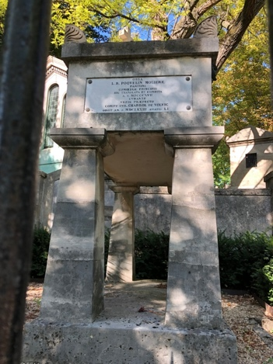
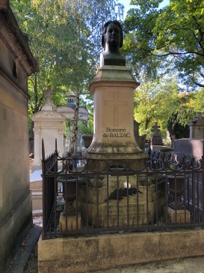All of a sudden, a booming loudspeaker announced the cemetery was closing in 30 minutes. I rushed clear across the park to Division 48, Honoré de Balzac’s gravesite. The well-marked tomb was easy to spot with Balzac’s bulbous bust of a head staring straight at me. This was a man whose personality was so large that it seemed to transcend death. An obese, caffeine-fueled workaholic who attracted every writer in Paris to his funeral, Balzac wrote of death, “Death unites as well as separates; it silences all paltry feeling.” A somewhat cryptic message, but the words made me feel connected to all these people in the cemetery. We all must face death. It is the only guarantee of life. Perhaps that certainty is the exact thing that gives life meaning. I remembered Victor Hugo’s words, “It is nothing to die. It is frightful not to live.”
A bell rang to announce that the cemetery was closing. I had run out of time.
And yet, I felt like Père Lachaise added years to my life.
